FIBO Specification Production Requirements

14 March 2014

Contents

Overview 3

Background 3

1. Metadata Reporting Requirements 3

Specification-level Metadata 4

Details 5

Module-level Metadata 5

Details 5

Ontology-level Metadata 6

Details 6

2. Diagram Reporting Requirements 7

3. Ontology Tables Reporting Requirements 8

Current Arrangements 8

Current Process 8

Table Requirements 9

Alternative Approach 9

Class Table Improvements 9

Changes in the Wizard: 9

Changes in the Tabular Structure 9

Properties Table Requirements 9

Restrictions Table Requirements 10

Restrictions Relationships 10

Logical Unions Requirements 11

Document Assembly / Sequencing 12

Desirable End Point 12

Changes to Adopted FIBO Specifications 13

Appendix 1: Chapter 9 Model Content Reports 14

9.1 Overview 14

9.1.1 Interpreting This Section 14

9.2. Module: Indicators 16

9.2.1 Ontology: Indicators Parameters 16

9.3 Module: Fx Rates 20

9.3.1 Ontology: Foreign Exchange 21

9.4 Module: Interest Rates 25

9.4.1 Ontology: Interest Rates 25

9.4.2 Ontology: Interest Rate Publishers 31

9.5 Module: Market Indicators 36

9.5.1 Ontology: Market Indicators 36

9.5.2 Ontology: Indicator Publishers 42

Appendix 2: Specification-level Metadata in Chapter 8 of FIBO Specifications 49

8.3 Ontology Architecture and Namespaces 49

# Overview

Reporting Capabilities are in two parts:

1. The specification components needed or in place;
2. Automation of the physical procedure for specification production, combing those elements in the most efficient way possible.

This document defines two kinds of requirement:

**Functional Requirement** – what the reports, diagrams etc. should be;

**Functional Requirement (document sequencing):** Where these should be placed within an overall report which can be pasted directly into the specification document as the “Model Content” chapter.

## Background

OMG submissions of FIBO standards includes the provision of formal written specifications. These are to a large extent boilerplate, with additional unique material being created on scope, conformance etc. on a specification by specification basis. However, one component of these specifications is a chapter reporting on the content of the FIBO models.

Because FIBO is a model driven set of specifications, no original model content is produced during the document editing process. Instead, a series of reports and other outputs are drawn from the model and placed within the “Chapter 9” section (hereinafter referred to as the “Model Content” section).

The overall requirements for these “Model Content” reports are summarized as follows:

1. Metadata – reported in tables at the beginning of each sub-clause in this chapter
2. Diagrams of the model content
3. Tabular reports on the model content

The models themselves are organized by “Modules”. The module is a namespace fragment which groups one of several ontologies according to a common theme. In the report, the modules are reported on as well as the individual ontologies within those modules.

Appendix 1 gives the “Model Content” chapter for the FIBO Indices and Indicators specification (initial draft). This is representative of the range of content to be expected in FIBO specifications generally.

# 1. Metadata Reporting Requirements

Metadata is contained within each ontology, but is reported at the level of Specification, Module and Ontology metadata.

All such metadata is defined within a single OMG ontology, the “SpecificationMetadata” ontology. This uses the namespace abbreviation “sm” within those ontologies. Each ontology contains specification metadata at the levels of:

* Family (in this case FIBO)
* Specification (for example “FIBO Indices and Indicators”)
* Module (for example “InterestRates”)
* Ontology (for example “InterestRatePublishers”)

Family-level metadata does not need to be included in these reports.

***Historical note:*** *at one point these were provided as a report from Cameo, in plain text (not tabulated). This was discontinued and tables were created by hand. The requirement now is to update that reporting requirement to recreate tables like the ones that are done by hand.*

## Specification-level Metadata

Metadata at the level of the overall FIBO “specification” is currently reported by hand in a separate “Architecture” chapter (Chapter 8). This includes for example specification abstract, specification abbreviation and so on, along with various elements of copyright and licensing information. The relevant portion of this chapter is included here as Appendix 2.

**Functional Requirement:** Create the Chapter 8 Specification Metadata tables, using the specification-level Specification Metadata from any one ontology in the submitted set.

**Functional Requirement:** Create the Chapter 8 tabular reports on the namespaces and dependencies for the current specification. This includes a listing of the namespaces and namespace abbreviations for the ontologies in other FIBO specifications upon which the current specification depends, and of external ontologies on which the current FIBO specification depends (these latter remain the same for all FIBO specifications so this could be maintained as hard text). Optionally, the completed specification may include all of the namespaces and namespace abbreviations for those other specifications, or it may read the ontology dependencies within the VOM models (being the complete set of both owl:Imports relations and sm:dependsOn relations), and report on just those ontologies’ namespaces and namespace abbreviations in these tables.

It will be acceptable to combine elements of what are currently separate tables in Chapter 8 if this makes production of the content easier or more efficient.

Metadata which is currently written out in plain text in the current Chapter 8 may also be reported in tables, for ease of production. The precise layout of the current Chapter 8 does not represent a hard and fast layout requirement.

All specification-level metadata shall only be reported once for the entire FIBO specification. It is repeated in each ontology but shall not be repeated in the specification document which reports on those.

Curation and rights metadata elements (copyright, submitter, contributor, license, responsible task force) are not required in these reports.

### Details

The SM elements which are identified as “Specification level” are the following:

sm:specificationTitle

sm:specificationAbbreviation

sm:specificationURL

sm:specificationAbstract

sm:dependsOn

sm:thisVersion

sm:publicationDate

sm:specificationVersionURL

sm:specificationVersionStatus

## Module-level Metadata

Module-level metadata is the same in each ontology within a given module. It shall only be reported on once.

Each module is introduced with a second-level heading within Chapter 9 (for example 9.2).

The report on the module-level metadata is given as a table immediately under the Module heading.

**Functional Requirement:** All model content identified as module-level metadata from the SM namespace shall be reported in a table.

**Functional Requirement (document sequencing)** the module-level metadata table shall be placed immediately after the Module-level heading for that module in the “Model Content” part of the specification.

### Details

The SM elements which are identified as “Module level” are the following:

sm:moduleName

sm:moduleAbbreviation

sm:moduleVersion

sm:moduleAbstract

## Ontology-level Metadata

This is identified as file metadata in the SM ontology. This is because this is intended to be used for types of file other than as well as ontologies.

The ontology-level metadata is reported in a table under the third-level heading which introduces the ontology.

Immediately under the ontology heading is plain text output of the text contained within the “File Abstract” metadata element.

**NOTE:** An exception to what is shown in the “Model Content” sample in the Annex, is that the table should also contain a row entry which not only outputs the File Abstract metadata element content, but also identifies it as such.

In addition to reporting on the SM-derived metadata, these tables also include ontology level properties or relationships, including owlImports relations.

**Functional Requirement:** All model content identified as file-level metadata shall be reported in a table.

**Functional Requirement:** OWL Imports relations shall be reported in the same table as the metadata, identifying the full path (not the namespace abbreviation) of the imports relations.

**Functional Requirement:** The OWL elements owl:versionIRI and the “Ontology IRI” are to be reported in this table.

**Functional Requirement (document sequencing)** The file-level metadata table shall be placed after the plain text rendition of the “File abstract” metadata content, which shall follow immediately after the level 3 sub-heading which introduces the ontology.

### Details

The SM elements which are identified as “File level” are the following:

sm:filename (Note that this reports a natural language label for the ontology and not a filename)

sm:fileAbbreviation

owl:versionIRI

sm:fileAbstract (Note that at present this is reported in plain text below the heading. To be added to tables as well)

sm:dependsOn

owl:imports

# 2. Diagram Reporting Requirements

The VOM model from which these reports are generated contains several styles of diagram. One such style is deemed the “Business” view of the content, for the purposes of these written specifications (note that this differs from the more truly business-facing diagrams described in the next section of this document).

Only one style of diagram goes in the written specification. This is identified as the “Business” diagram. These are maintained within a separate UML file folder from other diagrams.

Every FIBO VOM ontology Cameo project has the following structure as standard for diagrams:

* There is a UML package called ”Diagrams”; this has sub-packages as follows:
  + Business Diagrams
  + Internal Diagrams
  + Tech Diagrams

**Functional Requirement:** All diagrams found within the “Business Diagrams” UML package shall be placed in the “Model Content” report section of the specification.

**Functional Requirement (document sequencing):** The diagrams are to be placed immediately following the metadata tables.

The order in which these are placed is immaterial. The document editor may later choose to re-order these by hand; there is no mechanism in place for defining the order in which they are to be reported.

# 3. Ontology Tables Reporting Requirements

Tables are provided for each ontology, containing the complete content of that ontology other than metadata and ontology-level relationships.

## Current Arrangements

These are presently created as a number of separate CSV files which are generated by a plug-in called “FIBO Profile”

The requirements described here cover two areas of scope:

1. Functional requirements of the present and future tables from which this material is generated
2. Requirements for combining the outputs of these within one overarching process, with as little manual intervention as is achievable within the current technology.

Scope are 2 above is included because the current process is time consuming and error prone.

## Current Process

This consists of

* Running up the plug-in, populating each of (currently three) tables via a macro and saving these as separate spreadsheets.
* Outside of the tool, collating these spreadsheets into larger spreadsheets at the level of the ontology, deleting unwanted columns, and then converting these into Word document tables
* The collation process currently also includes a number of manual operations to recreate content that is not currently reported on by the plug-in tables. These include
  + Detailed relationships around restrictions, in the largely empty restrictions tables (cell entries added by hand)
  + Logical unions, which are not reported in a table at all (rows added by hand)

**Functional Requirements (document sequencing):**

* There is a column called “Owner” which currently reports the ontology within which the element is located (in fact for the Restrictions table it reports the class on which this is a restriction; so this probably reflects more UML-centric view of ownership).
  + This column is not required in the completed tabular reports in the “Model Content” specification material. It is currently retained during the collation process and removed at the end. In considering how to automate the end to end production of the document, this may be retained during the process or not, but it must disappear by the time the overall “Model Content” material is ready for inclusion in the formal specification.
* There is a column simply headed “#”. This shall be removed in the completed report.

## Table Requirements

* Existing: Table for “Class”, as seen
* Existing: Table for “Property” as seen
* Incomplete: Table for “Restriction”
* New requirement: Table for “unionClass” with all relationships.

Improvements are also required in the existing tables.

### Alternative Approach

If instead of working to improve the existing plug-in and tables, a new approach is chosen, then a detailed specification of what currently goes into the different cells of those existing tables can be made available. This is in the form of a spreadsheet.

## Class Table Improvements

### Changes in the Wizard:

**Change Requirement:** The wizard used to populate this table shall automatically exclude or delete the two classes “Thing” and “Nothing” which are currently reported.

### Changes in the Tabular Structure

*Note each of the three tables has roughly similar headings, but these differ textually because of some limitation in the tool. Requirements are framed here without reference to the exact text or casing style used for these column headings.*

This includes two similar columns, identified as Simple Type and Related Thing. Due to a now irrelevant bug, one of these was reporting the content from the other as well as its own. These are now to be combined, with a new column heading “Related Thing or Type”, retaining the column which reports content from both types of element.

**Functional Requirement:** Delete the column identified as “Simple Type”. Also delete this column in the other two tables (Classes and Restrictions) so that the table structures continue to align.

## Properties Table Requirements

On running the table population wizard, this currently reports two of each property, with two separate graphical icons or styles (these may or may not be the association elements and class elements of the UML Association Class used to represent properties).

**Change Requirement:** Remove the duplicate entries for each property. When running the existing wizard, these are the ones where the icon looks like a tiny circle. Retain the ones where the icon looks like a rectangle. This is the one for which the correct content of these elements appears to be reported in the spreadsheets.

## Restrictions Table Requirements

This is more complex, and new ideas are being experimented with. The sample “Model Content” material given in the annex shows the current thinking. Note that the “definition” part of this is considered problematic, however no better suggestions have been made on this.

Overall there are two requirements for this table, one of which has been met:

1. Report on each Restriction, with its name and label, in the table
2. Add certain entries into certain columns of the table, corresponding to the “range” or “client end” (UML or OWL terminology) of each of the several relationships that have that restriction as its domain (or supplier) end.

The mapping between these relationships and the columns is not straight forward.

### Restrictions Relationships

**Functional Requirement:** The following relationships exist or may exist for each OWL Restriction and shall be reported on if present. None of these appears more than once per restriction but some may not be present in all restrictions:

* onProperty: this is an ODM stereotype on a UML Dependency relationship representing an OWL element.
  + The range or client end of this (for the avoidance of doubt, the “pointy end”) always refers to the UML Association Class element which corresponds to an OWL property (one of two possible stereotypes, owlObjectProperty and owlDatatypeProperty).
  + The label of this remote element shall be placed in the “Property” column
* allValuesFrom OR someValuesFrom OR valuesFrom OR onClass: at most one of these may be present in the model. These are each an ODM stereotype on a UML dependency, representing an OWL element of that name.
  + The range or client (pointy end) of the relationship points either to a UML class which represents an OWL Class, or to a UML class which represents a datatype.
  + The label of the remote UML class shall be placed in the “Related Thing or Type” column
* **Multiples Column:** the column labeled “Multiples” shall have one of three possible types of text placed within it (this is currently done by hand)
  + Cardinality: if the Restriction class has within it a “cardinality” element then a natural language textual description of that cardinality shall be placed in the Multiples column
    - For example, minCardinality=0 shall be reported as “min 0” or similar
    - There is some flexibility as to exactly how this is reported but it shall not include words which are part of the working language of modelers, such as “cardinality” or “Multiplicity”
  + allValluesFrom: if the relationship identified in the second bullet above is of the stereotype “allValuesFrom” then the text placed in the Multiples column shall read “may only be”
  + someValuesFrom: if the relationship identified in the second bullet above is of the stereotype “someValuesFrom” then the text placed in the Multiples column shall read “must be some”
  + It is not expected that a Restriction will have both cardinality and either of the two relationships allValuesForm and someValueFrom. If it does the model is in error. The ability to flag up such an error would be a bonus but is not a formal requirement. The reporting feature shall elegantly handle any such error, either by reporting one or the other type of content (and not for example crash or freeze) .
* **Definition Column:** Currently the model does not contain definition metadata for these. Instead one of a set of three possible standard wordings is created, again by hand. Anything which replicates or improves upon this would be good.

## Logical Unions Requirements

**Functional Requirement:** A new table is required, in the same style as the preceding ones and with the same column headings. This shall report on each element with the stereotype “unionClass” within the ontology.

Each union class has two or more relationships which are stereotypes on the “Generalization” UML relationship. The supplier end (for the avoidance of doubt, the non-pointy end) is attached to one UML Class in each case, representing an OWL class.

**Functional Requirement:** the label for each of the OWL classes which is at the supplier or blunt end of a UML Generalization relationship whose client (pointy) end is the union being reported on, shall be included in the “Related Thing or Type” column. There is always at least two of these, and no defined upper limit, therefore the column shall list them all, within the same cell. A natural language delimiter (such as semi-colon) may be used or a line break may be inserted, but whatever method is used these shall be identifiably separate distinct while being contained within the same spreadsheet or Word table cell.

# Document Assembly / Sequencing

As described against each of the above reporting features, there is a need to combine these in the most effective manner possible within the limitations of the available technology, to surpass the existing manual process for assembly, with automation of all or parts of the process.

The precise sequencing requirements are identified in the preceding sections, in terms of where everything shall end up.

Rather than specify exactly how this shall be achieved, this section will be merely descriptive of the goal of this functionality.

**Goal:** Assemble reports into specification document as an OMG deliverable

This may be anything between:

* Production of the entire “Model Content” material (metadata, diagrams and tables sequenced as described);
* Automation of the production of what are now separate tables within a given VOM project, into one action, taking in any of – within one VOM ontology project:
  + the cloning of the plug-in tables to the Tables UML Package in the ontology project;
  + table population from the wizard macros by running one macro that combines these and deletes the unwanted items as described
* or across VOM Projects: combining and creating the above across the entire Specification VOM model structure (this is likely to prove too ambitious)
* Collation of the separate spreadsheets produced within each VOM module, into a single table per ontology as described in the preceding sections
* Or simply reducing the number of keystrokes required to create and collate the spreadsheets, combine these with the diagrams, and insert the metadata and headings.

### Desirable End Point

An acceptable end point for these changes would be as follows:

* Ontology modeler generates the tables from within each individual ontology (ideally combined into one population wizard and one save of the output)
* Report generator creates a draft report of the “Module Content” chapter containing metadata tables and diagrams placed as described in the preceding section
* The tables output from each ontology are transformed into Word tables on a per ontology basis, with as little additional processing as possible (e.g. columns which are not needed are excluded from what the plug-in tables generate as output) and these are then dropped into the specification by the specification editor at the appropriate points
* Chapter heading numbering is not enabled (due to the nature of the OMG template, creating precisely numbered headings for this chapter causes impossible maintenance challenges to the rest of the document)

# Changes to Adopted FIBO Specifications

A new set of requirements is being identified, which has not previously been reported on in any automated way. This is the requirement that, for a given FIBO specification, any proposed changes that are to be made to existing FIBO specifications also be recorded in that specification.

This will likely take the form of a new chapter of the specification. Existing tables and diagrams are currently used to show what the resultant updated content is to look like, and this uses all of the same mechanisms described above.

Additional requirements may follow in this area, for example for the tabular reporting of individual classes and properties. Alternatively these may be edited by hand by the specification editor.

# Appendix 1: Chapter 9 Model Content Reports

## 9.1 Overview

This section lists all the terms, definitions and relationships in the Indices and Indicators models defined in this specification.

Please note that this section is not intended to be read by business subject matter experts; for this purpose, tabular reports or spreadsheets should be produced for this audience as described elsewhere in this specification.

### 9.1.1 Interpreting This Section

This section shows each of the components of the model with their OWL construct names where applicable. These are:

| **Construct Name** | **Description** |
| --- | --- |
| **Module:** | A grouping of ontologies with some common theme. These also share a namespace fragment in the corresponding OWL files. |
| **Ontology** | A single OWL ontology. |
| **Class of Thing** | An OWL Class, that is a set theoretic construct representing a common set of properties, possession of which would make any individual a member of this set. |
| **Relationship property** | The Class named as “Range” for the relationship represents something in terms of which the meaning of the relationship is framed.  Known as “object property” in OWL. |
| **Parent** | **“is a”** relationships - these have no definition. This relationship indicates that the Class is a sub-class of the Class to which the relationship is pointing. |
| **Simple property** | Some property framed in terms of some simple type of information such as text or a “yes or no” value.  Known as “datatype property” in OWL. |
| **Datatype Property Range** | The type of information in which the OWL Datatype Property is framed  Known as “Type” in the tables, where one column combines types of simple properties, and related things (ranges) of relationship properties  NOTE: for some simple properties, the range is a DataEnumeration (see below). |
| **Data Enumeration** | These item represent a selection of possible values, which are intended to be taken as literal (e.g. textual) values. A “Simple property” (OWL Datatype Property) may identify one of these as the Simple property Type; this means that any one of the values in the list may be a possible value for this property. |
| **Logical Union** | A logical union of Classes. The membership of the union is shown in this report in the “Related thing or type” column. |
| **Mutually exclusive** | Identifies two sets of which no one individual may be a member of both.  Known as “disjoint” in OWL. |
| **Definition** | The SKOS Definition annotation, giving the formal definition of the item |
| **Explanatory Note** | An annotation giving more detailed business facing explanations for concepts. |
| **Editorial Note** | The SKOS Editorial Note annotation, giving additional editorial narrative about the term and definition. |
| **Term Origin** | The origin of the concept in some external source, which was directly used as a point of reference in deriving the concept indicated. |
| **Definition Origin** | The origin of the written definition for the concept in some external source, which was directly used as a point of reference in deriving the concept indicated. |
| **Restriction** | A set theoretic construct representing the re-use or refinement of an existing relationship property. The restriction represents a set of things in the business domain, the set being everything which has the stated relationship restricted as shown. Restrictions may be a super-class of some class of thing (representing a necessary condition for membership of that class) or they may be shown as “equivalent to” that class of thing, meaning that the restriction represents necessary and sufficient conditions for membership of that class. |

## 9.2. Module: Indicators

Table 9.1 Indicators Module Metadata

|  |  |
| --- | --- |
| **Metadata Term** | **Value** |
| **sm:moduleName** | Indicators |
| **sm:moduleAbbreviation** | FIBO-IND-IND |
| **sm:moduleVersion** | 1.0 |
| **sm:moduleAbstract** | This module includes ontologies for concepts common to all types of market index and market indicator or economic measure. These are all types of numeric parameter which vary over time, and are published by some source. These are divided into concepts descriptive of the numeric parameter, and concepts descriptive of the values which those parameters take over time. |

### 9.2.1 Ontology: Indicators Parameters

This ontology provides the concepts common to all market rates, indices and indicators; that is concepts descriptive of the numeric parameters themselves. These are modeled independently of the values they may take over time.

Table 9.2 Indicators Parameters Ontology Metadata

| **Metadata Term** | **Value** |
| --- | --- |
| **sm:filename** | Indicators Parameters |
| **sm:fileAbbreviation** | fibo-ind-ind-par |
| **OntologyIRI** | http://www.omg.org/spec/EDMC-FIBO/IND/Indicators/IndicatorsParameters/ |
| **owl:versionIRI** | http://www.omg.org/spec/EDMC-FIBO/IND/20140201/Indicators/IndicatorsParameters/ |
| **sm:dependsOn** | http://www.omg.org/techprocess/ab/SpecificationMetadata/  http://www.omg.org/spec/EDMC-FIBO/FND/Utilities/AnnotationVocabulary/ |

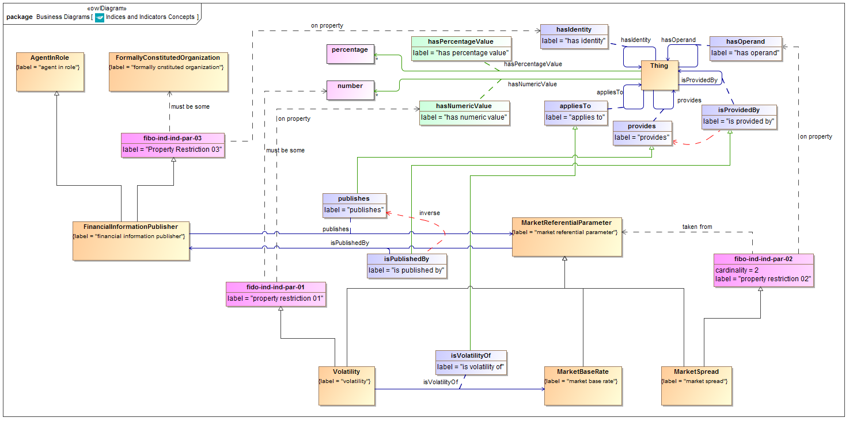

**Figure 9.1 Indicators Parameters Concepts**

Diagram showing all of the concepts in the Indicators Parameters ontology.

Table 9.3 Indicators Parameters Details

| **Concept Type** | **Name** | **Type Of Thing** | **Property** | **Definition** | **Parent** | **Mutually Exclusive With** | **Related Thing or Type** | **Inverse Of Property** | **Multiples** | **Editorial Note** | **Explanatory Note** | **Term Origin** | **Definition Source** |
| --- | --- | --- | --- | --- | --- | --- | --- | --- | --- | --- | --- | --- | --- |
| Class | Volatility | volatility |  | A measure of security price fluctuation. Mathematically the volatility is the annualized standard deviation of a security's daily price changes | market referential parameter property restriction 01 |  |  |  |  |  |  |  |  |
| Class | MarketSpread | market spread |  | A published figure giving the difference (known as the spread) between two different market rates. | market referential parameter property restriction 02 |  |  |  |  |  |  |  |  |
| Class | MarketReferentialParameter | market referential parameter |  | A published parameter about financial or other markets, such as an index, an indicator or an interest rate. |  |  |  |  |  |  |  |  |  |
| Class | MarketBaseRate | market base rate |  | Calculated notional value used to measure market trends for a set of instruments (S&P500, NASDAQ composite, 30day CD) or express economical climate for an industry (DowJones Industrial, H&Q Growth Technologies) and/or political region (Libor, Prime) | market referential parameter |  |  |  |  |  | Calculated notional value used to measure market trends for a set of instruments. Includes regions, economies, and so on. Hence sub sets for different types of market bases. |  |  |
| Class | FinancialInformationPublisher | financial information publisher |  | Some entity acting in the capacity of a publisher or provider of information which is related to the financial markets, or which is of interest to financial market participants such as information on economies. | agent in role Property Restriction 03 |  |  |  |  |  |  |  |  |
| Relationship Property | publishes | financial information publisher | publishes | Makes information publicly available in the form of some market referential paramater including economic indices, investment indices and economic indicators. | provides |  | market referential parameter | is published by |  |  |  |  |  |
| Relationship Property | isVolatilityOf | volatility | is volatility of | The market rate to which the volatility measure applies and of which it is a measure. | applies to |  | market base rate |  |  |  |  |  |  |
| Relationship Property | isPublishedBy | market referential parameter | is published by | That which is acting in the role of publisher of this information, being some entity which makes this information available to the publc by some means. | is provided by |  | financial information publisher | publishes |  |  |  |  |  |
| Property Restriction | fido-ind-ind-par-01 | property restriction 01 | has numeric value | Set of things with the property shown, where at least one participant in that relationship must be taken from the type of thing indicated. |  |  | number |  | must be some |  |  |  |  |
| Property Restriction | fibo-ind-ind-par-02 | property restriction 02 | has operand | Set of things that have the property shown, in the multiples given, taken from the type of thing indicated. |  |  | market referential parameter |  | equals 2 |  |  |  |  |
| Property Restriction | fibo-ind-ind-par-03 | Property Restriction 03 | has identity | Set of things with the property shown, where at least one participant in that relationship must be taken from the type of thing indicated. |  |  | formally constituted organization |  | must be some |  |  |  |  |

## 9.3 Module: Fx Rates

Table 9.4 Fx Rates Module Metadata

|  |  |
| --- | --- |
| **Metadata Term** | **Value** |
| **sm:moduleName** | FxRates |
| **sm:moduleAbbreviation** | FIBO-IND-FX |
| **sm:moduleVersion** | 1.0 |
| **sm:moduleAbstract** | This module includes ontologies defining concepts to do with foreign exchange. |

### 9.3.1 Ontology: Foreign Exchange

This ontology provides the parameters for foreign exchange rates, covering spot and forward rates, as well as Fx spot rate volatilities.

Table 9.5 Foreign Exchange Ontology Metadata

|  |  |
| --- | --- |
| **Metadata Term** | **Value** |
| **sm:filename** | ForeignExchange |
| **sm:fileAbbreviation** | fibo-ind-fx-fxr |
| **OntologyIRI** | http://www.omg.org/spec/EDMC-FIBO/IND/FxRates/ForeignExchange/ |
| **owl:versionIRI** | http://www.omg.org/spec/EDMC-FIBO/IND/20140201/FxRates/ForeignExchange/ |
| **sm:dependsOn** | http://www.omg.org/techprocess/ab/SpecificationMetadata/  http://www.omg.org/spec/EDMC-FIBO/FND/Utilities/AnnotationVocabulary/ |

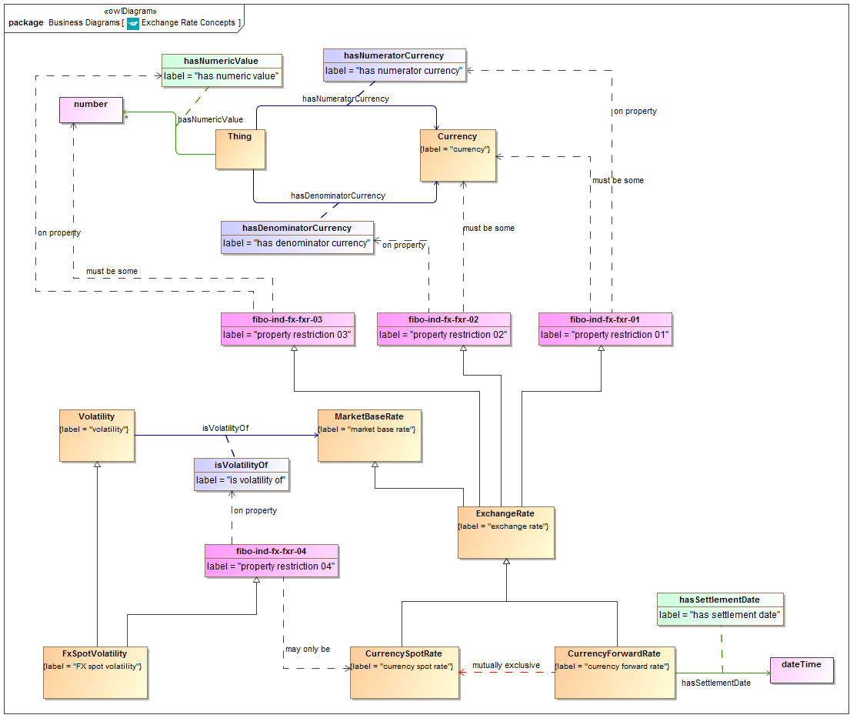

**Figure 9.2 Foreign Exchange Concepts**

Diagram showing all of the concepts in the Foreign Exchange ontology.

Table 9.6 Foreign Exchange Details

| **Concept Type** | **Name** | **Type Of Thing** | **Property** | **Definition** | **Parent** | **Mutually Exclusive With** | **Related Thing or Type** | **Inverse Of Property** | **Multiples** | **Editorial Note** | **Explanatory Note** | **Term Origin** | **Definition Source** |
| --- | --- | --- | --- | --- | --- | --- | --- | --- | --- | --- | --- | --- | --- |
| Class | FxSpotVolatility | FX spot volatility |  | A measure of exchange rate fluctuation. Mathematically the volatility is the annualized standard deviation of the daily changes in the exchange rate, | volatility property restriction 04 |  |  |  |  |  |  |  |  |
| Class | ExchangeRate | exchange rate |  | A rate of exchange between two currencies, expressed as the ratio between a number of units of the numerator currency to one unit of the denominator currency. | property restriction 01 property restriction 02 property restriction 03 market base rate |  |  |  |  |  |  |  |  |
| Class | CurrencySpotRate | currency spot rate |  | The exchange rate at a point in time, with settlement at that same point in time. | exchange rate | currency forward rate |  |  |  |  |  |  |  |
| Class | CurrencyForwardRate | currency forward rate |  | The rate of exchange between the two currencies, expressed as a ratio of number of units of the numerator to one unit of the denominator currency, for settlement at some future point in time. | exchange rate | currency spot rate |  |  |  |  |  |  |  |
| Simple Property | hasSettlementDate | currency forward rate | has settlement date | The date for forward settlement of currency transactions at this forward exchange rate. |  |  | xsd:dateTime |  |  |  |  |  |  |
| Relationship Property | hasNumeratorCurrency |  | has numerator currency | The currency used as the numerator of the exchange rate. R units of this currency represent one unit of the denominator currency. |  |  | currency |  |  |  |  |  |  |
| Relationship Property | hasDenominatorCurrency |  | has denominator currency | The currency used as the denominator of the exchange rate. One unit of this currency represents R units of the numerator currency, where R is the Exchange Rate value. |  |  | currency |  |  |  |  |  |  |
| Property Restriction | fibo-ind-fx-fxr-01 | property restriction 01 | has numerator currency | Set of things with the property shown, where at least one participant in that relationship must be taken from the type of thing indicated. |  |  | currency |  | must be some |  |  |  |  |
| Property Restriction | fibo-ind-fx-fxr-02 | property restriction 02 | has denominator currency | Set of things with the property shown, where at least one participant in that relationship must be taken from the type of thing indicated. |  |  | currency |  | must be some |  |  |  |  |
| Property Restriction | fibo-ind-fx-fxr-03 | property restriction 03 | has numeric value | Set of things with the property shown, where at least one participant in that relationship must be taken from the type of thing indicated. |  |  | number |  | must be some |  |  |  |  |
| Property Restriction | fibo-ind-fx-fxr-04 | property restriction 04 | is volatility of | Set of things which, if they have the property shown, any participants in that relationship may only be taken from the type of thing indicated. |  |  | currency spot rate |  | may only be |  |  |  |  |

## 9.4 Module: Interest Rates

Table 9.7 Interest Rates Module Metadata

|  |  |
| --- | --- |
| **Metadata Term** | **Value** |
| **sm:moduleName** | InterestRates |
| **sm:moduleAbbreviation** | FIBO-IND-IR |
| **sm:moduleVersion** | 1.0 |
| **sm:moduleAbstract** | This module includes ontologies defining concepts to do with interest rates, that is rates of interest paid on capital by banks and other lenders, including inter-bank lending rates and rates of certain representative debt instruments. |

### 9.4.1 Ontology: Interest Rates

This ontology provides the basic types of interest rate which are recognized in the financial markets, and the relationships between these where applicable. These include bank base rates, inter-bank offer rates, overnight rates of interest and the US Federal Funds rate which is widely used as a rate of reference. It also includes the concept of a market rate spread between two interest rates.

Table 9.8 Interest Rates Ontology Metadata

|  |  |
| --- | --- |
| **Metadata Term** | **Value** |
| **sm:filename** | InterestRates |
| **sm:fileAbbreviation** | fibo-ind-ir-ir |
| **OntologyIRI** | http://www.omg.org/spec/EDMC-FIBO/IND/InterestRates/InterestRates/ |
| **owl:versionIRI** | http://www.omg.org/spec/EDMC-FIBO/IND/20140201/InterestRates/InterestRates/ |
| **sm:dependsOn** | http://www.omg.org/techprocess/ab/SpecificationMetadata/  http://www.omg.org/spec/EDMC-FIBO/FND/Utilities/AnnotationVocabulary/ |

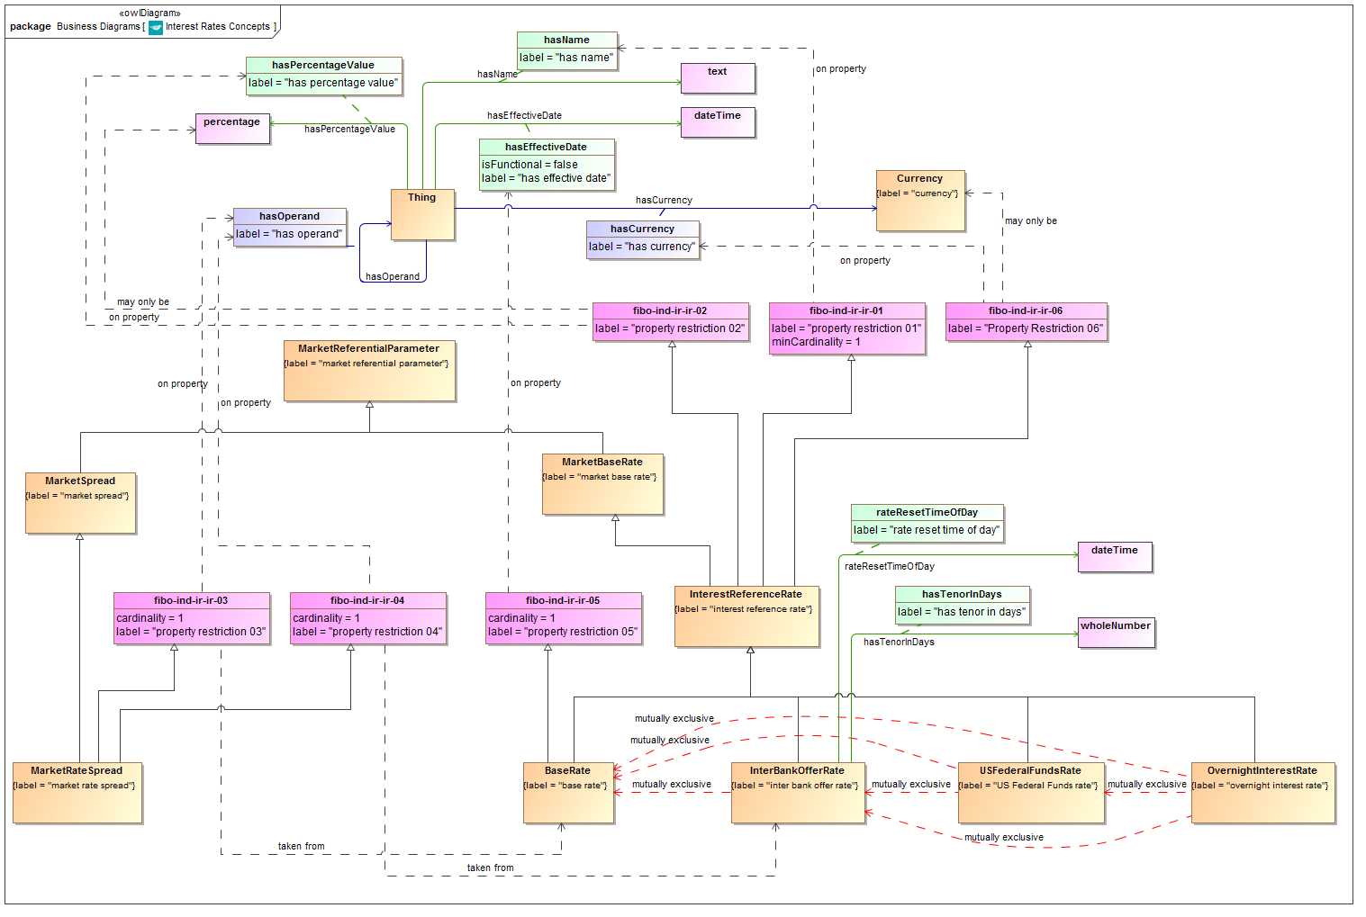

**Figure 9.3 Interest Rates Concepts**

Diagram showing all of the concepts in the Interest Rates ontology.

Table 9.9 Interest Rates Details

| **Concept Type** | **Name** | **Type Of Thing** | **Property** | **Definition** | **Parent** | **Mutually Exclusive With** | **Related Thing or Type** | **Inverse Of Property** | **Multiples** | **Editorial Note** | **Explanatory Note** | **Term Origin** | **Definition Source** |
| --- | --- | --- | --- | --- | --- | --- | --- | --- | --- | --- | --- | --- | --- |
| Class | BaseRate | base rate |  | The base rate set by a central bank for a given currency. | interest reference rate property restriction 05 | overnight interest rate inter bank offer rate US Federal Funds rate |  |  |  |  | This is set at intervals. |  |  |
| Class | InterBankOfferRate | inter bank offer rate |  | A interest rate at which banks lend to one another. | interest reference rate | US Federal Funds rate overnight interest rate base rate |  |  |  |  |  |  |  |
| Class | InterestReferenceRate | interest reference rate |  | a rate of interest paid by or agreed among some bank or set of banks | market base rate property restriction 01 property restriction 02 Property Restriction 06 |  |  |  |  |  |  |  |  |
| Class | MarketRateSpread | market rate spread |  | A rate formed from the difference between an interest rate and a lending rate, each for a given duration. | market spread property restriction 03 property restriction 04 |  |  |  |  |  | An example of this is a TED spread specifically for LIBOR and Fed funds Rate. |  |  |
| Class | OvernightInterestRate | overnight interest rate |  | The rate of interest that is offered for overnight deposits. | interest reference rate | base rate inter bank offer rate US Federal Funds rate |  |  |  |  | This forms the underlying in Overnight Interest Rate Swaps (IOS). |  |  |
| Class | USFederalFundsRate | US Federal Funds rate |  | The effective fed funds rate is a dollar-weighted average of interest rates payable on overnight Fed funds. It is compiled daily by the New York Federal Reserve Bank and is based on transactions arranged by major brokers. | interest reference rate | overnight interest rate inter bank offer rate base rate |  |  |  |  |  |  |  |
| Simple Property | hasTenorInDays | inter bank offer rate | has tenor in days | The length of time for which the IBOR is quoted, e.g. 3 months, 6 months and so on. |  |  | whole number |  |  | This is given as a whole number representing the number of days, because the concept of a duration is not yet modeled semantically, otherwise this term would refer to duration as its range instead. The name of this property reflects this compromise and would be changed to "Tenor" once a suitable range exists for this property. |  |  |  |
| Simple Property | rateResetTimeOfDay | inter bank offer rate | rate reset time of day | The time of day when the rate is reset e.g. 11:00 |  |  | xsd:dateTime |  |  |  |  |  |  |
| Property Restriction | fibo-ind-ir-ir-01 | property restriction 01 | has name | Set of things that have the property shown, in the multiples given, taken from the type of thing indicated. |  |  |  |  | at least 1 |  |  |  |  |
| Property Restriction | fibo-ind-ir-ir-02 | property restriction 02 | has percentage value | Set of things which, if they have the property shown, any participants in that relationship may only be taken from the type of thing indicated. |  |  | percentage |  | may only be |  |  |  |  |
| Property Restriction | fibo-ind-ir-ir-03 | property restriction 03 | has operand | Set of things that have the property shown, in the multiples given, taken from the type of thing indicated. |  |  | base rate |  | exactly 1 |  |  |  |  |
| Property Restriction | fibo-ind-ir-ir-04 | property restriction 04 | has operand | Set of things that have the property shown, in the multiples given, taken from the type of thing indicated. |  |  | interbank offer rate |  | exactly 1 |  |  |  |  |
| Property Restriction | fibo-ind-ir-ir-05 | property restriction 05 | has effective date | Set of things that have the property shown, in the multiples given, taken from the type of thing indicated. |  |  |  |  | exactly 1 |  |  |  |  |
| Property Restriction | fibo-ind-ir-ir-06 | Property Restriction 06 | has currency | Set of things which, if they have the property shown, any participants in that relationship may only be taken from the type of thing indicated. |  |  | currency |  | may only be |  |  |  |  |

### 9.4.2 Ontology: Interest Rate Publishers

This ontology provides concepts descriptive of the publishers of interest rates, such as banks and the bodies which publish inter-bank offer rates.

Table 9.10 Interest Rate Publishers Ontology Metadata

|  |  |
| --- | --- |
| **Metadata Term** | **Value** |
| **sm:filename** | InterestRatePublishers |
| **sm:fileAbbreviation** | fibo-ind-ir-pub |
| **OntologyIRI** | http://www.omg.org/spec/EDMC-FIBO/IND/InterestRates/InterestRatePublishers/ |
| **owl:versionIRI** | http://www.omg.org/spec/EDMC-FIBO/IND/20140201/InterestRates/InterestRatePublishers/ |
| **sm:dependsOn** | http://www.omg.org/techprocess/ab/SpecificationMetadata/  http://www.omg.org/spec/EDMC-FIBO/FND/Utilities/AnnotationVocabulary/ |

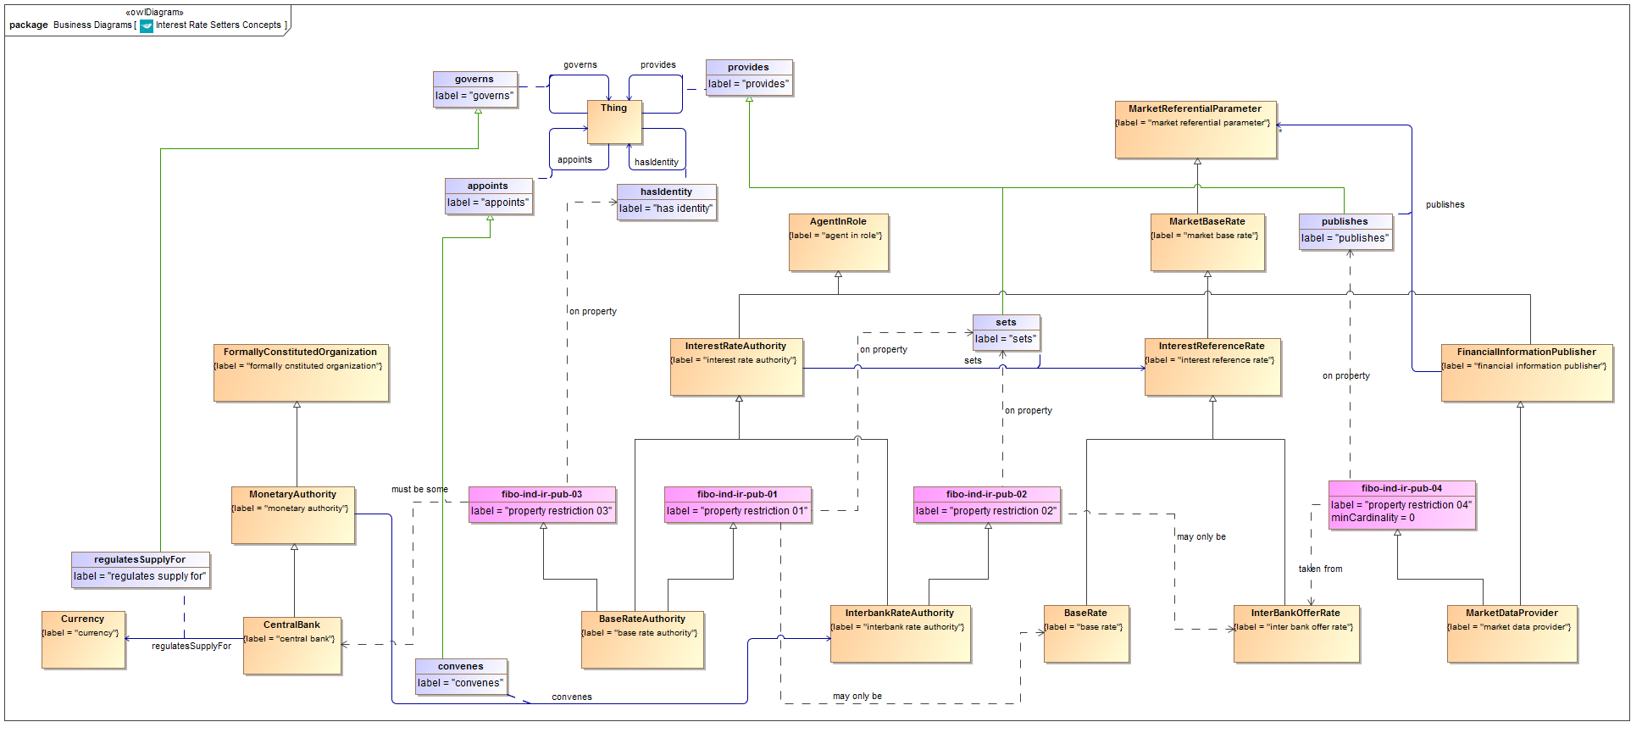

**Figure 9.4 Interest Rate Publishers Concepts**

Diagram showing all of the concepts in the Interest Rate Publishers ontology.

Table 9.11 Interest Rate Publishers Details

| **Concept Type** | **Name** | **Type Of Thing** | **Property** | **Definition** | **Parent** | **Mutually Exclusive With** | **Related Thing or Type** | **Inverse Of Property** | **Multiples** | **Editorial Note** | **Explanatory Note** | **Term Origin** | **Definition Source** |
| --- | --- | --- | --- | --- | --- | --- | --- | --- | --- | --- | --- | --- | --- |
| Class | BaseRateAuthority | base rate authority |  | The authority responsible for setting the base rate for a given currency. This would normally be a central bank. | interest rate authority property restriction 01 property restriction 03 |  |  |  |  |  |  |  |  |
| Class | CentralBank | central bank |  | A bank which regulates the monetary supply for a given economy and currency. | monetary authority |  |  |  |  |  |  |  |  |
| Class | InterbankRateAuthority | interbank rate authority |  | The authority responsible for setting the Interbank lending rate. | interest rate authority property restriction 02 |  |  |  |  | Note that since the time of cunducting the reviews that led to these definitions, the LIBOR scandal took place in Londonand many of the arrangements described here have changed. There are other variations in how different interbank offer rates are set, which may also vary from what is modeled here or may have changed. | This is announced by the relevant Central Bank at intervals following a meeting of the relevant policy group or committee. Thomson Reuters is the publisher for LIBOR, but this is set by the British Bankers Association (BBA). |  |  |
| Class | InterestRateAuthority | interest rate authority |  | The authority or entity which is responsible for the publication of some interest rate. | agent in role |  |  |  |  |  | Interest rates which are referred to as market base rates, for example as used in interest rate derivatives, are published by some body which is responsible for the rate as a kind of market data. In general, all market data is not only information, but information published by someone. |  |  |
| Class | MarketDataProvider | market data provider |  | An entity which provides data or information about the financial markets. This is usually either a publishing house or a specialized market data vendor. | financial information publisher property restriction 04 |  |  |  |  |  |  |  |  |
| Class | MonetaryAuthority | monetary authority |  | Proxy for MarketAuthority, to enable the addition of assertions in this ontology. |  |  |  |  |  | Added as a proxy to support the assertion "convenes" which has this as a domain and InterbankRateAuthority as its range |  |  |  |
| Relationship Property | regulatesSupplyFor | central bank | regulates supply for | The currency issued by the central bank and for which it is responsible for the money supply. | governs |  | currency |  |  |  |  |  |  |
| Relationship Property | sets | interest rate authority | sets | The interest rate authority (such as a central bank or monetary authority or a panel working behalf of such) determines and sets the interest reference rate which is in force at a given time. | provides |  | interest reference rate |  |  |  |  |  |  |
| Relationship Property | convenes | monetary authority | convenes | The body responsible for setting the interbank offer rate is convened by or on behalf of the central bank or some other monetary authority. | appoints |  | interbank rate authority |  |  |  | An Interbank Lending Rate is announced by the relevant Central Bank at intervals following a meeting of the relevant policy group or committee. |  |  |
| Property Restriction | fibo-ind-ir-pub-01 | property restriction 01 | sets | Set of things which, if they have the property shown, any participants in that relationship may only be taken from the type of thing indicated. |  |  | base rate |  | may only be |  |  |  |  |
| Property Restriction | fibo-ind-ir-pub-02 | property restriction 02 | sets | Set of things which, if they have the property shown, any participants in that relationship may only be taken from the type of thing indicated. |  |  | interbank offer rate |  | may only be |  |  |  |  |
| Property Restriction | fibo-ind-ir-pub-03 | property restriction 03 | has identity | Set of things with the property shown, where at least one participant in that relationship must be taken from the type of thing indicated. |  |  | central bank |  | must be some |  |  |  |  |
| Property Restriction | fibo-ind-ir-pub-04 | property restriction 04 | publishes | Set of things that have the property shown, in the multiples given, taken from the type of thing indicated. |  |  | interbank offer rate |  | at least 0 |  |  |  |  |

## 9.5 Module: Market Indicators

Table 9.12 Market Indicators Module Metadata

|  |  |
| --- | --- |
| **Metadata Term** | **Value** |
| **sm:moduleName** | MarketIndicators |
| **sm:moduleAbbreviation** | FIBO-IND-MEI |
| **sm:moduleVersion** | 1.0 |
| **sm:moduleAbstract** | This module includes ontologies defining concepts to do with published economic indicators. These give some indication of the state of some economy. Indicators of this type are usually published by governments or government agencies, or by international agencies or agencies of countries other than the ones reported on. Examples include Gross Domestic Product (GDP) and unemployment rates. |

### 9.5.1 Ontology: Market Indicators

This ontology provides the parameters which make up the various types of market economic indicators, along with basic facts about these such as the economies or countries they apply to.

Table 9.13 Market Indicators Ontology Metadata

| **Metadata Term** | **Value** |
| --- | --- |
| **sm:filename** | MarketIndicators |
| **sm:fileAbbreviation** | fibo-ind-mei-mei |
| **OntologyIRI** | http://www.omg.org/spec/EDMC-FIBO/IND/MarketIndicators/MarketIndicators/ |
| **owl:versionIRI** | http://www.omg.org/spec/EDMC-FIBO/IND/20140201/MarketIndicators/MarketIndicators/ |
| **sm:dependsOn** | http://www.omg.org/techprocess/ab/SpecificationMetadata/  http://www.omg.org/spec/EDMC-FIBO/FND/Utilities/AnnotationVocabulary/ |

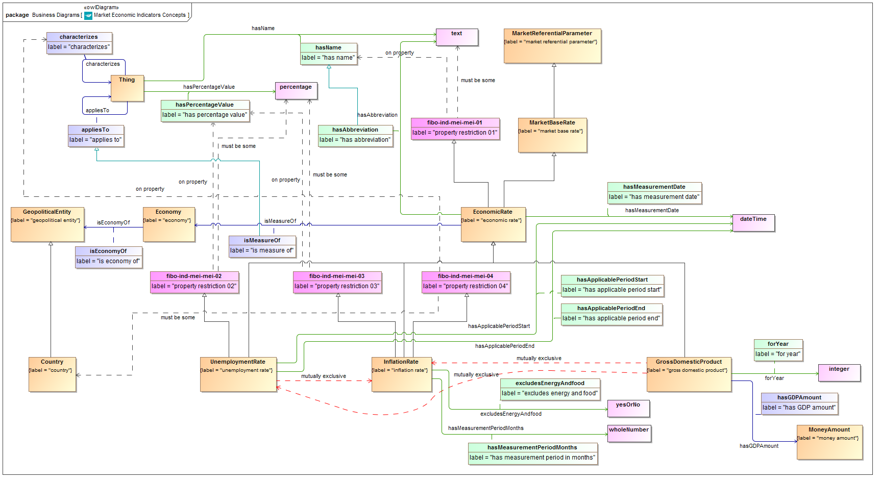

**Figure 9.5 Market Indicators Concepts**

Diagram showing all of the concepts in the Market Indicators ontology.

Table 9.14 Market Indicators Details

| **Concept Type** | **Name** | **Type Of Thing** | **Property** | **Definition** | **Parent** | **Mutually Exclusive With** | **Related Thing or Type** | **Inverse Of Property** | **Multiples** | **Editorial Note** | **Explanatory Note** | **Term Origin** | **Definition Source** |
| --- | --- | --- | --- | --- | --- | --- | --- | --- | --- | --- | --- | --- | --- |
| Class | EconomicRate | economic rate |  | A market based Index as published by some entity to provide a some measure of economic performance. | market base rate property restriction 01 |  |  |  |  |  |  |  |  |
| Class | Economy | economy |  | A geographically distinct web of economic relationships. |  |  |  |  |  |  |  |  |  |
| Class | GrossDomesticProduct | gross domestic product |  | The total output of the economy. | economic rate | unemployment rate inflation rate |  |  |  |  |  |  |  |
| Class | InflationRate | inflation rate |  | The annual percent change in consumer prices compared with the previous year's consumer prices, for a given country. | economic rate property restriction 03 property restriction 04 | unemployment rate gross domestic product |  |  |  |  |  |  |  |
| Class | UnemploymentRate | unemployment rate |  | A published rate of unemployment for a given economy. | economic rate property restriction 02 | gross domestic product inflation rate |  |  |  |  |  |  |  |
| Relationship Property | isMeasureOf | economic rate | is measure of | The economy of which the econmic rate applies. | applies to |  | economy |  |  |  |  |  |  |
| Simple Property | hasMeasurementDate | economic rate | has measurement date | The date at which the published figure applies. |  |  | xsd:dateTime |  |  |  |  |  |  |
| Simple Property | hasAbbreviation | economic rate | has abbreviation | The recognized abbreviation of the Index, e.g. RPI. | has name |  | text |  |  |  |  |  |  |
| Relationship Property | isEconomyOf | economy | is economy of | The geographical region, area etc. or the geopolitical construct (state, country) in which the economy is defined. |  |  | geopolitical entity |  |  |  |  |  |  |
| Relationship Property | hasGDPAmount | gross domestic product | has GDP amount | The actual value of the GDP for the applicable period, stated as a monetary amount. |  |  | money amount |  |  |  |  |  |  |
| Simple Property | forYear | gross domestic product | for year | The year for which the GDP figure applies. |  |  | xsd:integer |  |  | Review whether this needs additional qualifying terms, e.g. the applicable year end for that country.  The year is represented as a whole number (integer) because it is not possible to reference a datatype here which represents a year. |  |  |  |
| Simple Property | hasMeasurementPeriodMonths | inflation rate | has measurement period in months | The period of time up to the quoted date, to which the inflation rate applies. |  |  | whole number |  |  | At present, since the conceptof a date period has not been modeled semantically, this is given simplyas a whole number which is the number of months, since this kind of figure is generally quoted in months. | For example, for an inflation rate quoted for the 6 months to December 2009, this would be 6 months. |  |  |
| Simple Property | excludesEnergyAndfood | inflation rate | excludes energy and food | Whether the index excludes energy and food prices. |  |  | yes or no |  |  |  |  |  |  |
| Simple Property | hasApplicablePeriodStart | unemployment rate | has applicable period start | Start of the period to which the stated value of the unemployment rate applies. |  |  | xsd:dateTime |  |  | The class "Unemployment Rate" or a class representing its value, should be framed in terms of a date period. Since the concept of a date period has not yet been modeled semantically, the property which would have been "Applicable Period" is instead modeled as two properties representing the start and end date of that period (this would be a period denominated in days). |  |  |  |
| Simple Property | hasApplicablePeriodEnd | unemployment rate | has applicable period end | End of the period to which the stated value of the unemployment rate applies. |  |  | xsd:dateTime |  |  | The class "Unemployment Rate" or a class representing its value, should be framed in terms of a date period. Since the concept of a date period has not yet been modeled semantically, the property which would have been "Applicable Period" is instead modeled as two properties representing the start and end date of that period (this would be a period denominated in days). |  |  |  |
| Property Restriction | fibo-ind-mei-mei-01 | property restriction 01 | has name | Set of things with the property shown, where at least one participant in that relationship must be taken from the type of thing indicated. |  |  | text |  | must be some |  |  |  |  |
| Property Restriction | fibo-ind-mei-mei-02 | property restriction 02 | has percentage value | Set of things with the property shown, where at least one participant in that relationship must be taken from the type of thing indicated. |  |  | percentage |  | must be some |  |  |  |  |
| Property Restriction | fibo-ind-mei-mei-03 | property restriction 03 | has percentage value | Set of things with the property shown, where at least one participant in that relationship must be taken from the type of thing indicated. |  |  | percentage |  | must be some |  |  |  |  |
| Property Restriction | fibo-ind-mei-mei-04 | property restriction 04 | characterizes | Set of things with the property shown, where at least one participant in that relationship must be taken from the type of thing indicated. |  |  | country |  | must be some |  |  |  |  |

### 9.5.2 Ontology: Indicator Publishers

This ontology provides concepts descriptive of the publishers of market indicators, such as gross domestic product, employment statistics, inflation rates and so on. These may include government or quasi-government bodies, international agencies, third parties and data providers.

Table 9.15 Indicator Publishers Ontology Metadata

|  |  |
| --- | --- |
| **Metadata Term** | **Value** |
| **sm:filename** | IndicatorPublishers |
| **sm:fileAbbreviation** | fibo-ind-mei-pub |
| **OntologyIRI** | http://www.omg.org/spec/EDMC-FIBO/IND/MarketIndicators/IndicatorPublishers/ |
| **owl:versionIRI** | http://www.omg.org/spec/EDMC-FIBO/IND/20140201/MarketIndicators/IndicatorPublishers/ |
| **sm:dependsOn** | http://www.omg.org/techprocess/ab/SpecificationMetadata/  http://www.omg.org/spec/EDMC-FIBO/FND/Utilities/AnnotationVocabulary/ |

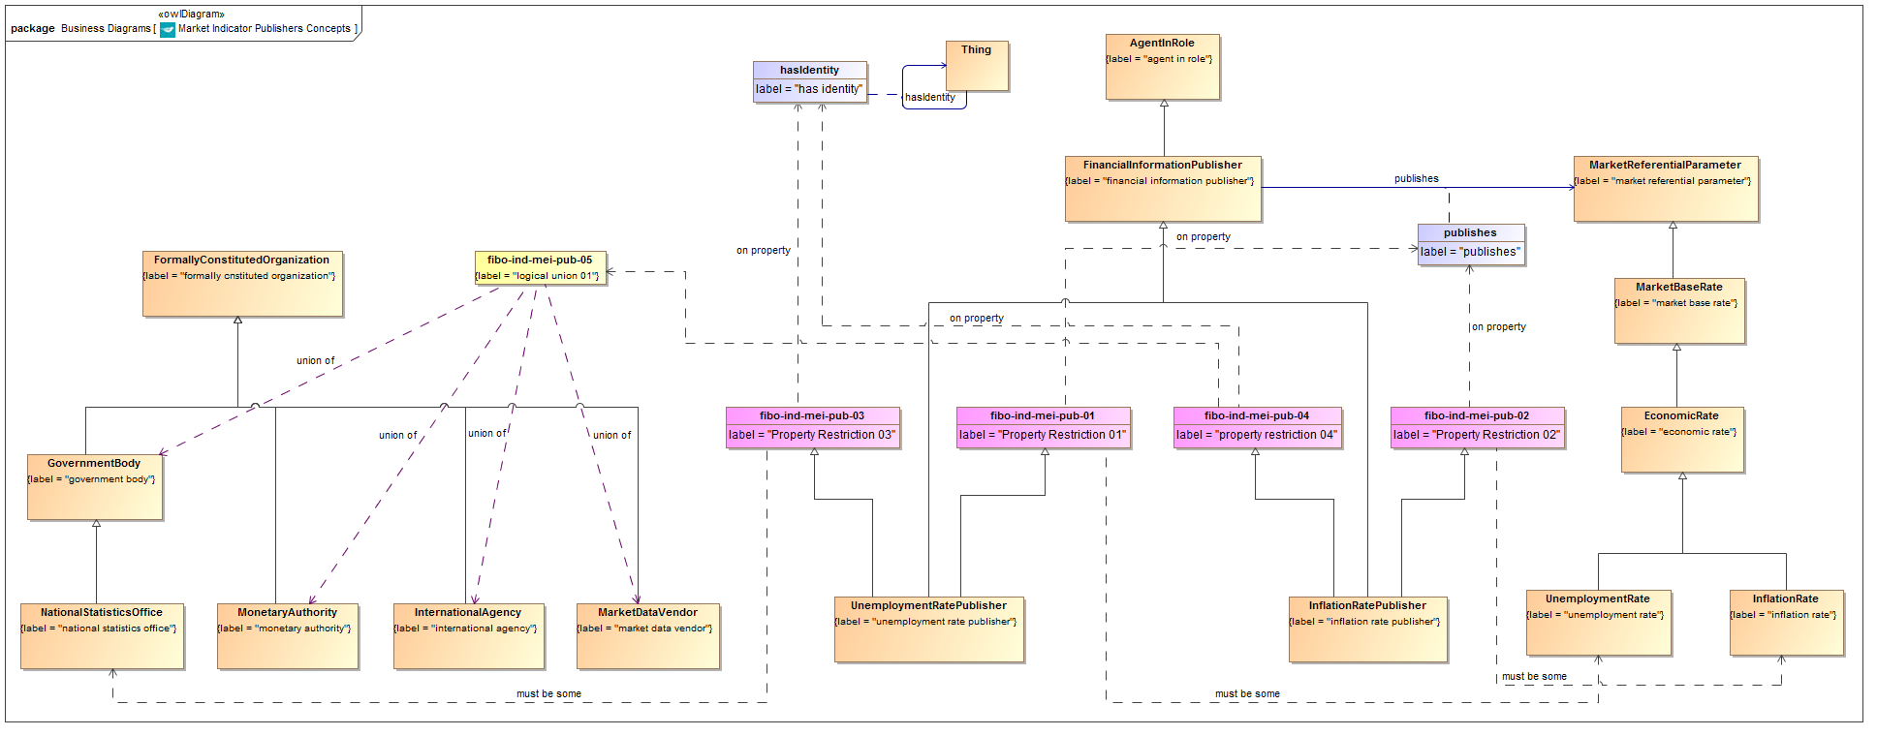

**Figure 9.6 Indicator Publishers Concepts**

Diagram showing all of the concepts in the Indicators Publishers ontology.

Table 9.16 Indicator Publishers Details

| **Concept Type** | **Name** | **Type Of Thing** | **Property** | **Definition** | **Parent** | **Mutually Exclusive With** | **Related Thing or Type** | **Inverse Of Property** | **Multiples** | **Editorial Note** | **Explanatory Note** | **Term Origin** | **Definition Source** |
| --- | --- | --- | --- | --- | --- | --- | --- | --- | --- | --- | --- | --- | --- |
| Class | GovernmentBody | government body |  | An individual organization which forms part of the mechanisms of government, and through which a government (which is a relative entity) discharges its functions in governing. | formally cnstituted organization |  |  |  |  | Definition to be reviewed; terms and hierarchies to be added for completeness. |  |  |  |
| Class | InflationRatePublisher | inflation rate publisher |  | The entity which publishes some inflation rate for a given economy | financial information publisher Property Restriction 02 property restriction 04 |  |  |  |  |  | Inflation rates maybe published by one of a variety of kinds of entity for the economy and rate in question. |  |  |
| Class | InternationalAgency | international agency |  | A body set up internationally which operates internationally. | formally cnstituted organization |  |  |  |  |  |  |  |  |
| Class | MarketDataVendor | market data vendor |  | A business entity which specializes in the sourcing and distribution of financial market data. | formally cnstituted organization |  |  |  |  |  |  |  |  |
| Class | MonetaryAuthority | monetary authority |  | Some formal organization tasked with some or all of the tasks relating to the monetary policy, regulation and supply for some currency or in some country or group of countries. | formally cnstituted organization |  |  |  |  | This item was added subsequent to the original SME reviews of this material. This item is referenced in InterestRatePublushers as the parent of CentralBank Meanwhile in this IndicatorsPublishers ontology, the union which previously included CentralBank now includes this concept instead. Rationale: A detailed description of the LIBOR arrangements was given at the time of the original SME reviews, and assumed to apply to other interbank offer rates. Subsequently the LIBOR scandal of 2012 led to considerable changes to these arrangements. In particular the panel responsible for setting LIBOR now answers to the Financial Conduct Authority (FCA). Similarly Euribor is set by a committee which is not convened by the European Central Bank. Therefore the more general concept of a Monetary Authority was introduced, of which central bank and (not shown) regulatory authorities would be examples. Many of the items which previously referenced CentralBank in both ontologies now reference this new concept. |  |  |  |
| Class | NationalStatisticsOffice | national statistics office |  | The government body responsible for publishing statistics for a country or economic area. | government body |  |  |  |  |  | Usually would be the publisher for both inflation rates and unemployment rates. For example in the US the same office provides unemployment rates and inflation rates. |  |  |
| Class | UnemploymentRatePublisher | unemployment rate publisher |  | The body which initially determines and publishes the unemployment rate for a given economic area. | financial information publisher Property Restriction 01 Property Restriction 03 |  |  |  |  |  |  |  |  |
| Restriction Property | fibo-ind-mei-pub-01 | Property Restriction 01 | publishes | Set of things with the property shown, where at least one participant in that relationship must be taken from the type of thing indicated. |  |  | unemployment rate |  | must be some |  |  |  |  |
| Restriction Property | fibo-ind-mei-pub-02 | Property Restriction 02 | publishes | Set of things with the property shown, where at least one participant in that relationship must be taken from the type of thing indicated. |  |  | inflation rate |  | must be some |  |  |  |  |
| Restriction Property | fibo-ind-mei-pub-03 | Property Restriction 03 | has identity | Set of things with the property shown, where at least one participant in that relationship must be taken from the type of thing indicated. |  |  | national statistics office |  | must be some |  |  |  |  |
| Restriction Property | fibo-ind-mei-pub-04 | property restriction 04 | has identity | Set of things with the property shown, where at least one participant in that relationship must be taken from the type of thing indicated. |  |  | logical union 01 |  | must be some |  |  |  |  |
| logical union | fibo-ind-mei-pub-05 | logical union 01 |  | Logical union of the items shown. |  |  | national statistics office, monetary authority, international agency, market data vendor |  |  |  |  |  |  |

# Appendix 2: Specification-level Metadata in Chapter 8 of FIBO Specifications

*This is reproduced here as it appears; however it may be reported differently and in a different order provided the information shown here is retained.*

*Any additional specification metadata which is not currently shown in this Appendix, shall also be included somewhere in the automatically generated Chapter 8 material.*

## 8.3 Ontology Architecture and Namespaces

As described in the FIBO Foundations specification in section 8.2, the ontology architecture for FIBO is designed to facilitate reuse and ontology evolution to the degree possible. An approach to the foundational terminology, including basic terminology describing amounts and rates, that provides very high-level, abstract conceptual knowledge designed to facilitate mapping is an important design goal. The basic building blocks for the Indices and Indicators (IND) Ontology, building on the architecture provided in Foundations, are shown in Figure 8.1, below.

As shown in the diagram, the IND ontologies are divided up into a number of *modules*. These include: Indicators (concepts common to more than one type of index or indicator), Foreign Exchange Rates, Interest Rates and Market Indicators.

The IND modules will ultimately depend on (1) Basic Terminology and Ontology Metadata (in light gray in the figure), (2) Foundations, (3) Business Entities and (4) a number of external modules, representing concepts for Natural Language, Geopolitical Entities (for example ISO 3166 Country codes, regional and municipal designations), and concepts defining dates, times, and durations. A sample set of these anticipated external resources are given in the dark gray layer in the figure.

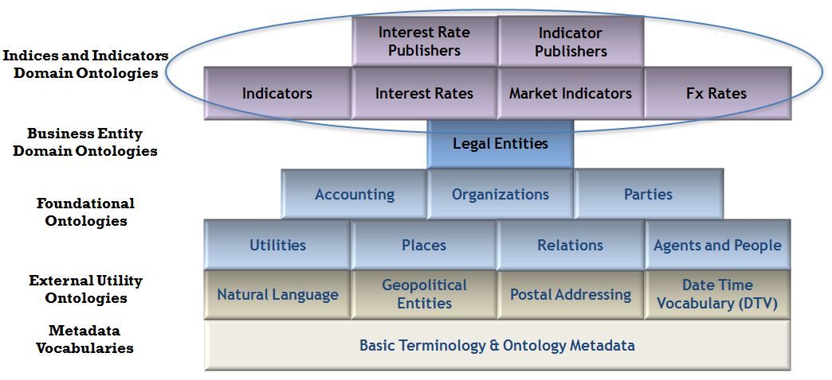

Figure 8.1 Indices and Indicators Ontology Architecture

The namespaces and their well-known prefixes corresponding to external elements required for use of FIBO Indices and Indicators include all of those listed in the FIBO Foundations specification and selected terms from the FIBO Business Entities specification, as well as those required for the use of Foundations itself. Table 8.1 lists those prefixes and namespaces considered external to Foundations. Table 8.2 provides those required for use of Foundations while Table 8.3 provides those required for use of the Business Entities specification (repeated here for convenience).

Table 8.1 Prefix and Namespaces for referenced/external vocabularies

|  |  |  |
| --- | --- | --- |
| Namespace Prefix | | Namespace |
| **rdf** | **http://www.w3.org/1999/02/22-rdf-syntax-ns#** | |
| **rdfs** | http://www.w3.org/2000/01/rdf-schema# | |
| **owl** | http://www.w3.org/2002/07/owl# | |
| **xsd** | http://www.w3.org/2001/XMLSchema# | |
| **dct** | http://purl.org/dc/terms/ | |
| **skos** | http://www.w3.org/2004/02/skos/core# | |
| **sm** | http://www.omg.org/techprocess/ab/SpecificationMetadata/ | |

Table 8.2 Prefix and Namespaces for FIBO Foundations

| Namespace Prefix | Namespace |
| --- | --- |
| **fibo-fnd-acc-aeq** | http://www.omg.org/spec/EDMC-FIBO/FND/Accounting/AccountingEquity/ |
| **fibo-fnd-acc-cur** | http://www.omg.org/spec/EDMC-FIBO/FND/Accounting/CurrencyAmount/ |
| **fibo-fnd-aap-agt** | http://www.omg.org/spec/EDMC-FIBO/FND/AgentsAndPeople/Agents/ |
| **fibo-fnd-aap-ppl** | http://www.omg.org/spec/EDMC-FIBO/FND/AgentsAndPeople/People/ |
| **fibo-fnd-agr-agr** | http://www.omg.org/spec/EDMC-FIBO/FND/Agreements/Agreements/ |
| **fibo-fnd-agr-ctr** | http://www.omg.org/spec/EDMC-FIBO/FND/Agreements/Contracts/ |
| **fibo-fnd-gao-gl** | http://www.omg.org/spec/EDMC-FIBO/FND/GoalsAndObjectives/Goals/ |
| **fibo-fnd-gao-obj** | http://www.omg.org/spec/EDMC-FIBO/FND/GoalsAndObjectives/Objectives/ |
| **fibo-fnd-law-jur** | http://www.omg.org/spec/EDMC-FIBO/FND/Law/Jurisdiction/ |
| **fibo-fnd-law-lcap** | http://www.omg.org/spec/EDMC-FIBO/FND/Law/LegalCapacity/ |
| **fibo-fnd-law-cor** | http://www.omg.org/spec/EDMC-FIBO/FND/Law/LegalCore/ |
| **fibo-fnd-org-fm** | http://www.omg.org/spec/EDMC-FIBO/FND/Organizations/FormalOrganizations/ |
| **fibo-fnd-org-lg** | http://www.omg.org/spec/EDMC-FIBO/FND/Organizations/LegitimateOrganizations/ |
| **fibo-fnd-org-org** | http://www.omg.org/spec/EDMC-FIBO/FND/Organizations/Organizations/ |
| **fibo-fnd-oac-ctl** | http://www.omg.org/spec/EDMC-FIBO/FND/OwnershipAndControl/Control/ |
| **fibo-fnd-oac-own** | http://www.omg.org/spec/EDMC-FIBO/FND/OwnershipAndControl/Ownership/ |
| **fibo-fnd-pty-pty** | http://www.omg.org/spec/EDMC-FIBO/FND/Parties/Parties/ |
| **fibo-fnd-pty-rl** | http://www.omg.org/spec/EDMC-FIBO/FND/Parties/Roles/ |
| **fibo-fnd-plc-adr** | http://www.omg.org/spec/EDMC-FIBO/FND/Places/Addresses/ |
| **fibo-fnd-plc-cty** | http://www.omg.org/spec/EDMC-FIBO/FND/Places/Countries/ |
| **fibo-fnd-plc-loc** | http://www.omg.org/spec/EDMC-FIBO/FND/Places/Locations/ |
| **fibo-fnd-rel-rel** | http://www.omg.org/spec/EDMC-FIBO/FND/Relations/Relations/ |
| **fibo-fnd-utl-av** | http://www.omg.org/spec/EDMC-FIBO/FND/Utilities/AnnotationVocabulary/ |
| **fibo-fnd-utl-bt** | http://www.omg.org/spec/EDMC-FIBO/FND/Utilities/BusinessFacingTypes/ |

Table 8.3 Prefix and Namespaces for FIBO Business Entities

|  |  |
| --- | --- |
| Namespace Prefix | Namespace |
| **fibo-be-oac-cpty** | **http://www.omg.org/spec/EDMC-FIBO/BE/OwnershipAndControl/ControlParties/** |
| **fibo-be-le-cb** | **http://www.omg.org/spec/EDMC-FIBO/BE/LegalEntities/CorporateBodies/** |
| **fibo-be-oac-cctl** | **http://www.omg.org/spec/EDMC-FIBO/BE/OwnershipAndControl/CorporateControl/** |
| **fibo-be-oac-cown** | **http://www.omg.org/spec/EDMC-FIBO/BE/OwnershipAndControl/CorporateOwnership/** |
| **fibo-be-corp-corp** | **http://www.omg.org/spec/EDMC-FIBO/BE/Corporations/Corporations/** |
| **fibo-be-le-fbo** | **http://www.omg.org/spec/EDMC-FIBO/BE/LegalEntities/FormalBusinessOrganizations/** |
| **fibo-be-oac-exec** | **http://www.omg.org/spec/EDMC-FIBO/BE/OwnershipAndControl/Executives/** |
| **fibo-be-fct-fct** | **http://www.omg.org/spec/EDMC-FIBO/BE/FunctionalEntities/FunctionalEntities/** |
| **fibo-be-le-lp** | **http://www.omg.org/spec/EDMC-FIBO/BE/LegalEntities/LegalPersons/** |
| **fibo-be-le-lei** | **http://www.omg.org/spec/EDMC-FIBO/BE/LegalEntities/LEIEntities/** |
| **fibo-be-oac-opty** | **http://www.omg.org/spec/EDMC-FIBO/BE/OwnershipAndControl/OwnershipParties/** |
| **fibo-be-ptr-ptr** | **http://www.omg.org/spec/EDMC-FIBO/BE/Partnerships/Partnerships/** |
| **fibo-be-tr-tr** | **http://www.omg.org/spec/EDMC-FIBO/BE/Trusts/Trusts/** |

As described in the [FIBO Foundations] specification, the namespace approach taken for FIBO is based on OMG guidelines and is constructed as follows:

* A standard prefix http://www.omg.org/spec/
* The family name, EDMC-FIBO
* The abbreviation for the specification: in this case IND
* The module name
* The ontology name

Note that the URI/IRI strategy for the ontologies in FIBO takes a “slash” rather than “hash” approach, in order to accommodate server-side applications. Though not technically necessary, this specification does mandate namespace prefixes to be used. These are constructed as follows with the components separated by “-“:

* The specification family name fibo
* The specification abbreviation: ind
* An abbreviation for the module name
* An abbreviation for the ontology name

The namespaces and prefixes corresponding to FIBO Indices and Indicators ontologies are summarized in Table 8.4 for convenience. These are given in alphabetical order, by module, rather than with any intent to show imports relationships.

Table 8.4 Prefix and Namespaces for FIBO Indices and Indicators

|  |  |
| --- | --- |
| Namespace Prefix | Namespace |
| **fibo-ind-ind-par** | **http://www.omg.org/spec/EDMC-FIBO/IND/Indicators/IndicatorsParameters/** |
| **fibo-ind-fx-fxr** | **http://www.omg.org/spec/EDMC-FIBO/IND/FxRates/ForeignExchange/** |
| **fibo-ind-ir-ir** | **http://www.omg.org/spec/EDMC-FIBO/IND/InterestRates/InterestRates/** |
| **fibo-ind-ir-pub** | **http://www.omg.org/spec/EDMC-FIBO/IND/InterestRates/InterestRatePublishers/** |
| **fibo-ind-mei-mei** | **http://www.omg.org/spec/EDMC-FIBO/IND/MarketIndicators/MarketIndicators/** |
| **fibo-ind-mei-pub** | **http://www.omg.org/spec/EDMC-FIBO/IND/MarketIndicators/IndicatorPublishers/** |
| **fibo-ind-inx-bsi** | **http://www.omg.org/spec/EDMC-FIBO/IND/MarketIndices/BasketIndices/** |
| **fibo-ind-inx-dri** | **http://www.omg.org/spec/EDMC-FIBO/IND/MarketIndices/CreditIndices/** |
| **fibo-ind-inx-pub** | **http://www.omg.org/spec/EDMC-FIBO/IND/MarketIndices/BasketIndexPublishers/** |